Windchill Performance Advisor Configuration
Schindler CRD Applications

Exported on 2025-08-19 06:32:53

Table of Contents

1 3
2 Delete Existing GUID 5
3 Generate new GUID 9
4 Enable Performance Advisor 12
5 Test Transport 13
6 Validate WPA Dashboard 14
7 Issues and Resolution 15
7.1 Test Transport Failed 15
7.1.1 Issue 15
7.1.2 Resolution 15
7.2 SSL handshake has read 0 bytes and written 325 bytes 19
7.2.1 Issue 19
7.2.2 Resolution 19
8 References 20

- Check Existing GUID Delete Existing GUID Generate new GUID Enable Performance Advisor Test Transport Validate WPA Dashboard Issues and Resolution Test Transport Failed Issue Resolution SSL handshake has read 0 bytes and written 325 bytes Issue Resolution References Check Existing GUID
- Delete Existing GUID
- Generate new GUID
- Enable Performance Advisor
- Test Transport
- Validate WPA Dashboard
- Issues and Resolution
  - Test Transport Failed
    - Issue
    - Resolution
  - SSL handshake has read 0 bytes and written 325 bytes
    - Issue
    - Resolution
- References
Check Existing GUID
- Windchill Performance Advisor need to be enabled on target server to send report to WPA dashboard.
- After upgrade GUID of target server is same as that of source server
- Navigate to Site > Utilities > Windchill Performance Advisor
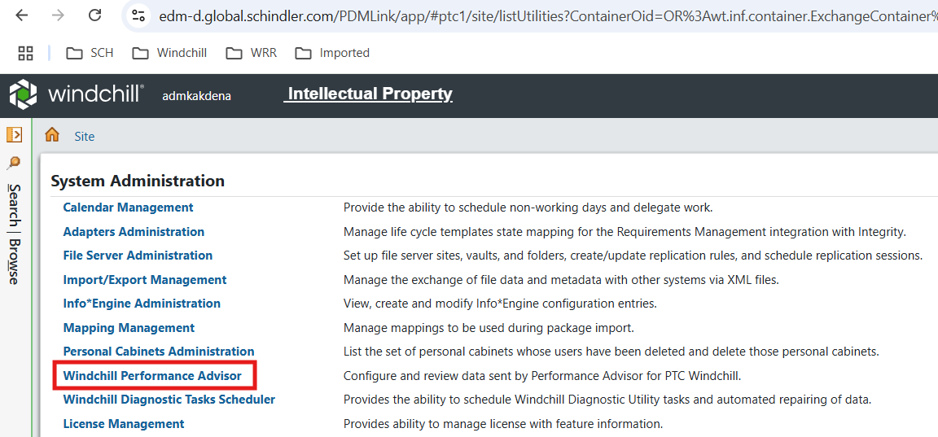
- Check GUID of target server. cf90950845969400da17c75b61dd2a9e3b9627c9 is the source server GUID.
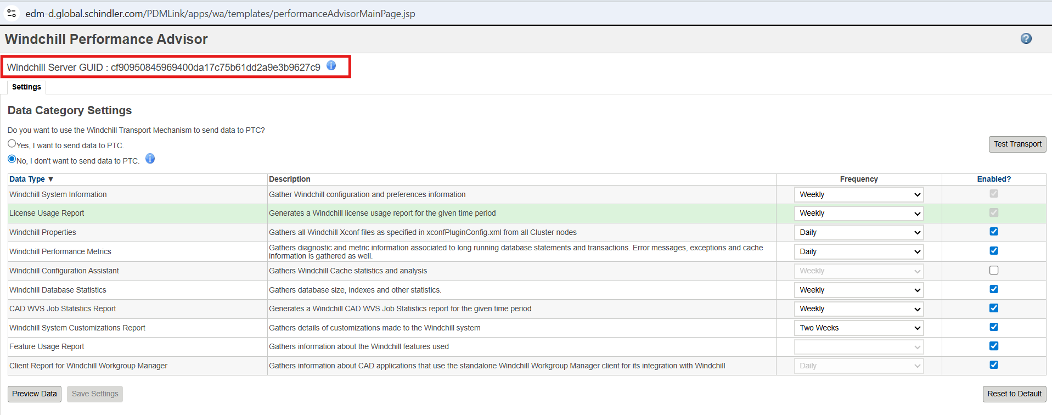

Delete Existing GUID
- Log to database using pdmlink user
Dev Server : SSHWSR2915
QA Server : SSHWSR2923
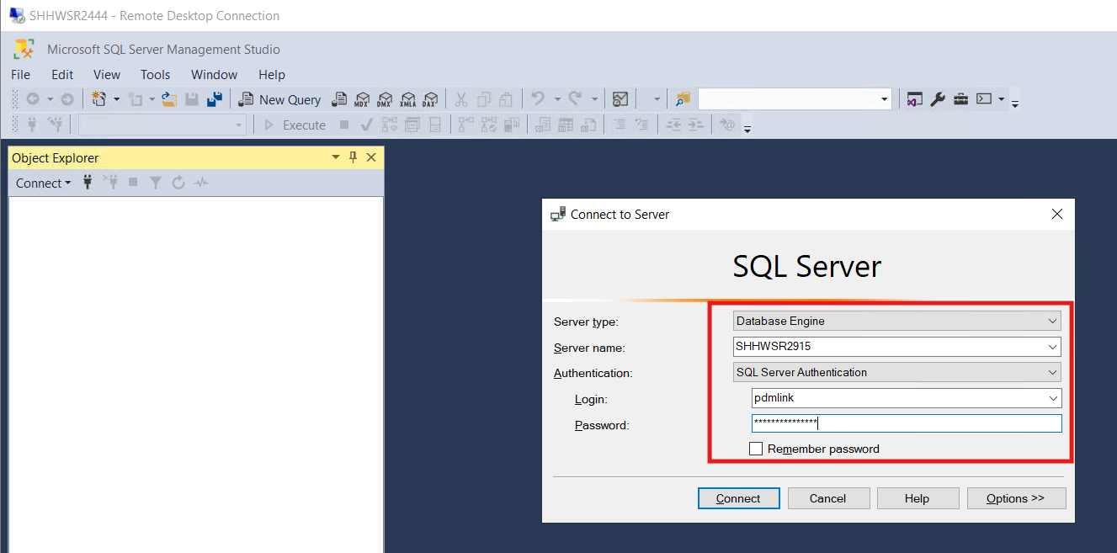
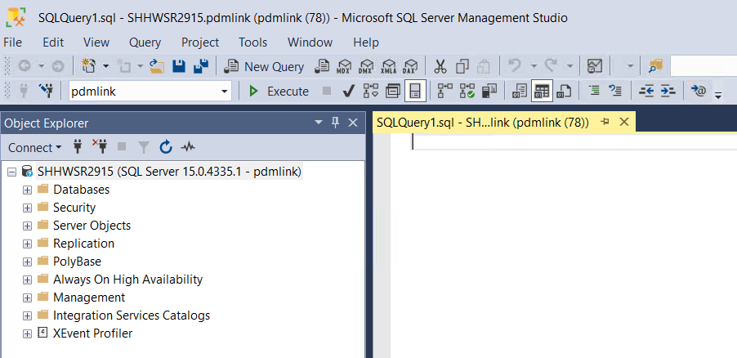
- Validate you are connected to correct database by executing below query
select * from FvHost;
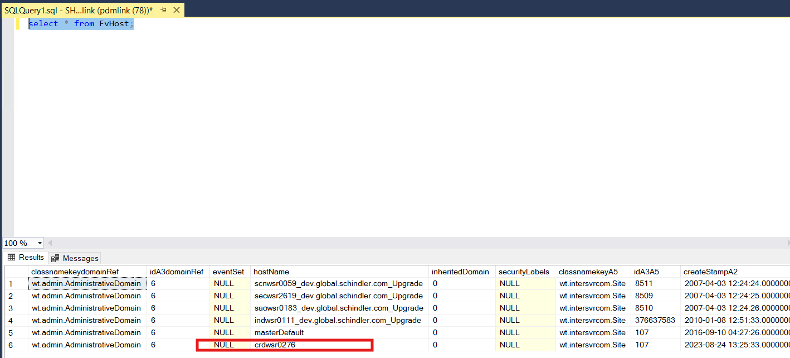
select * from Site;
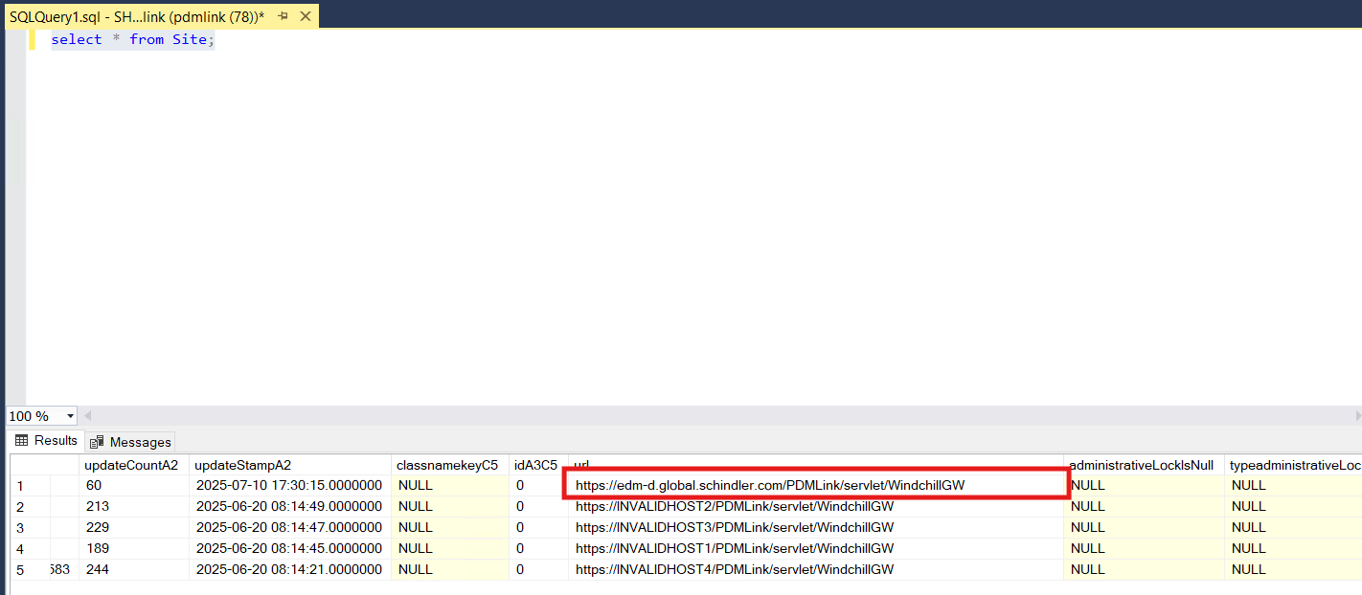
- Take backup of Repository table by executing below query
SELECT * INTO Repository_23072025 FROM Repository ;
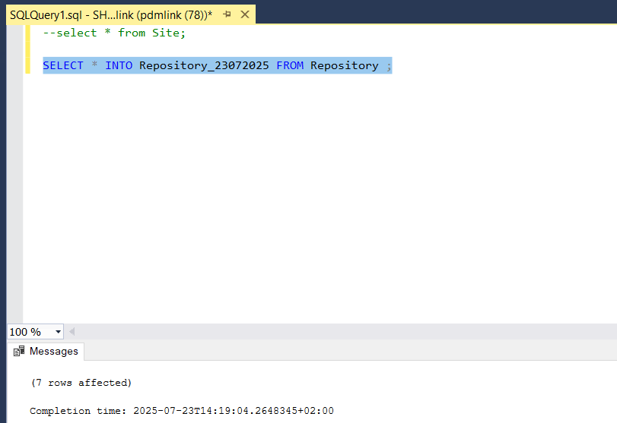
- Validate backup table is created by executing below query.
select * from Repository_23072025;
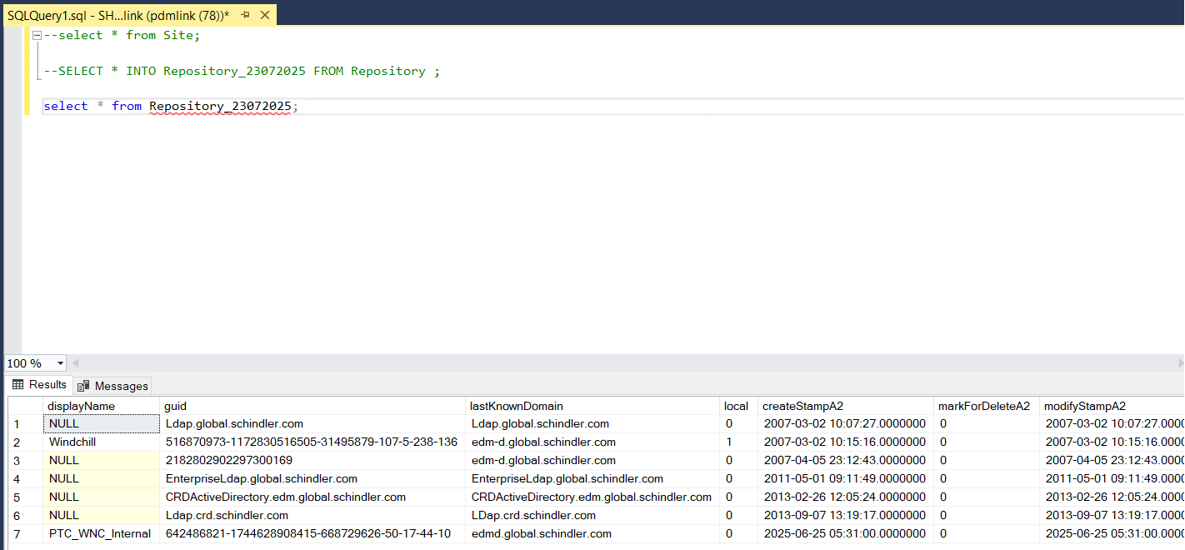
- Copy ida2a2 value of displayName PTC_WNC_Internal rows and execute below query
delete from Repository where idA2A2='23920539658';
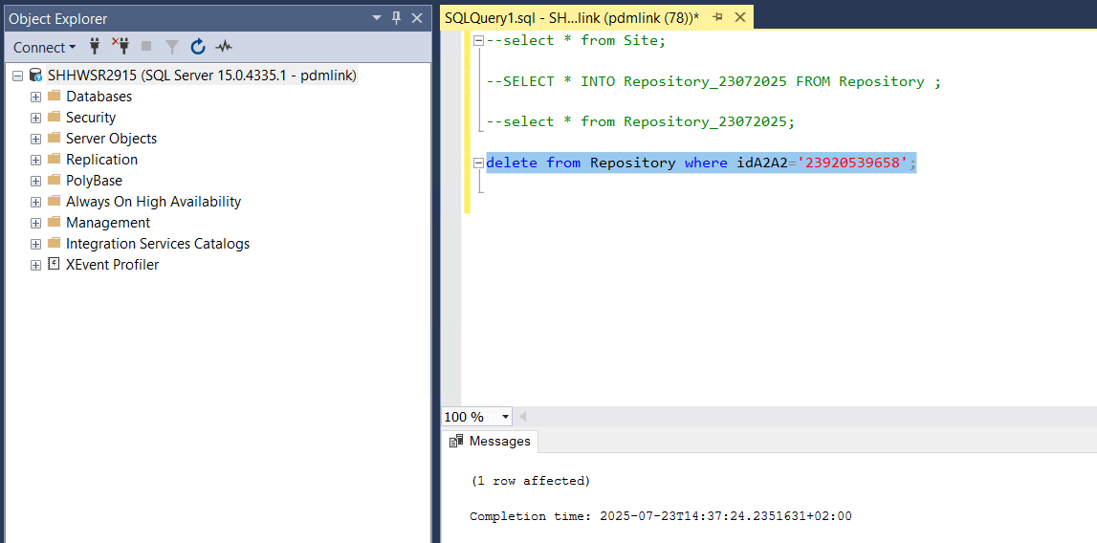
- validate entry is deleted using below query
select * from Repository;
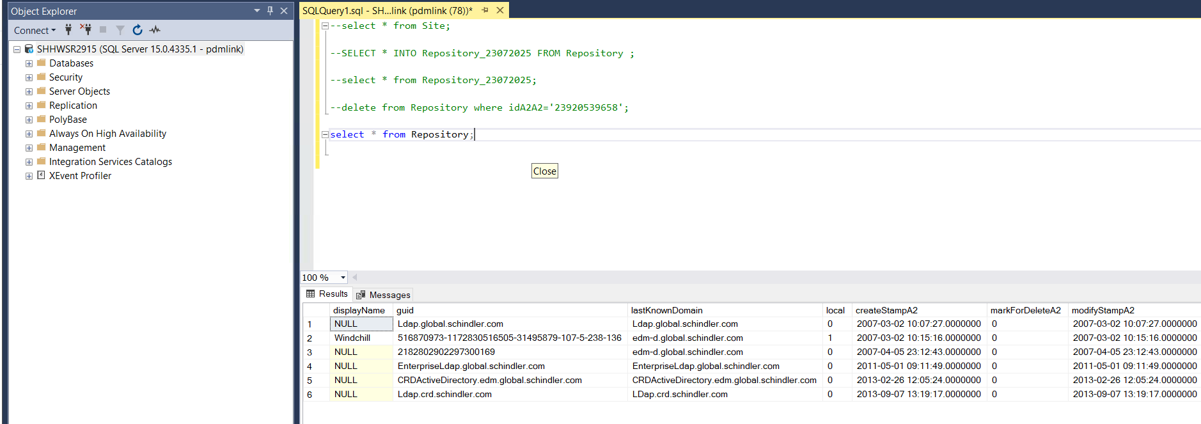

Generate new GUID
- To generate a new WPA GUID for a target system run the following command from a Windchill shell on the target system
windchill com.ptc.wa.WAUtility -generateguid -username=<username> -password=<password>
where:
<username> is a Windchill admin username
<password> is the Windchill admin password
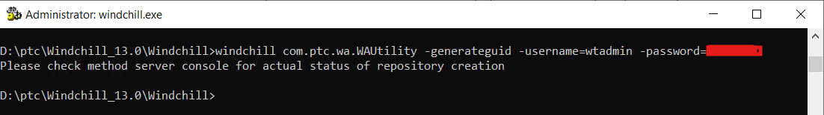
- Verify below message is printed in MS logs
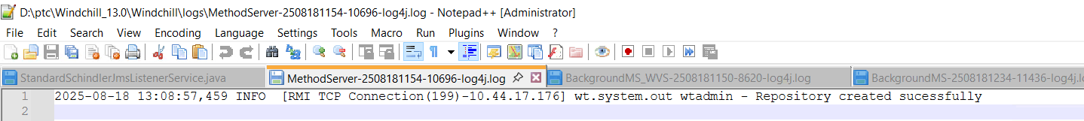
- Validate new GUID is updated in Site > Utilities > Windchill Performance Advisor
Dev Server :
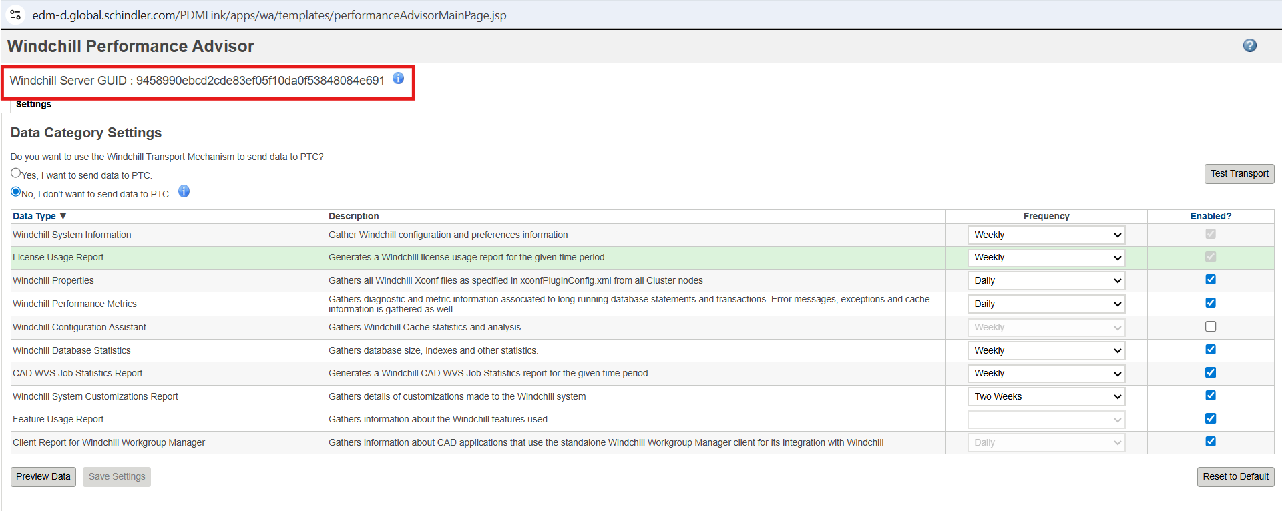
QA Server :
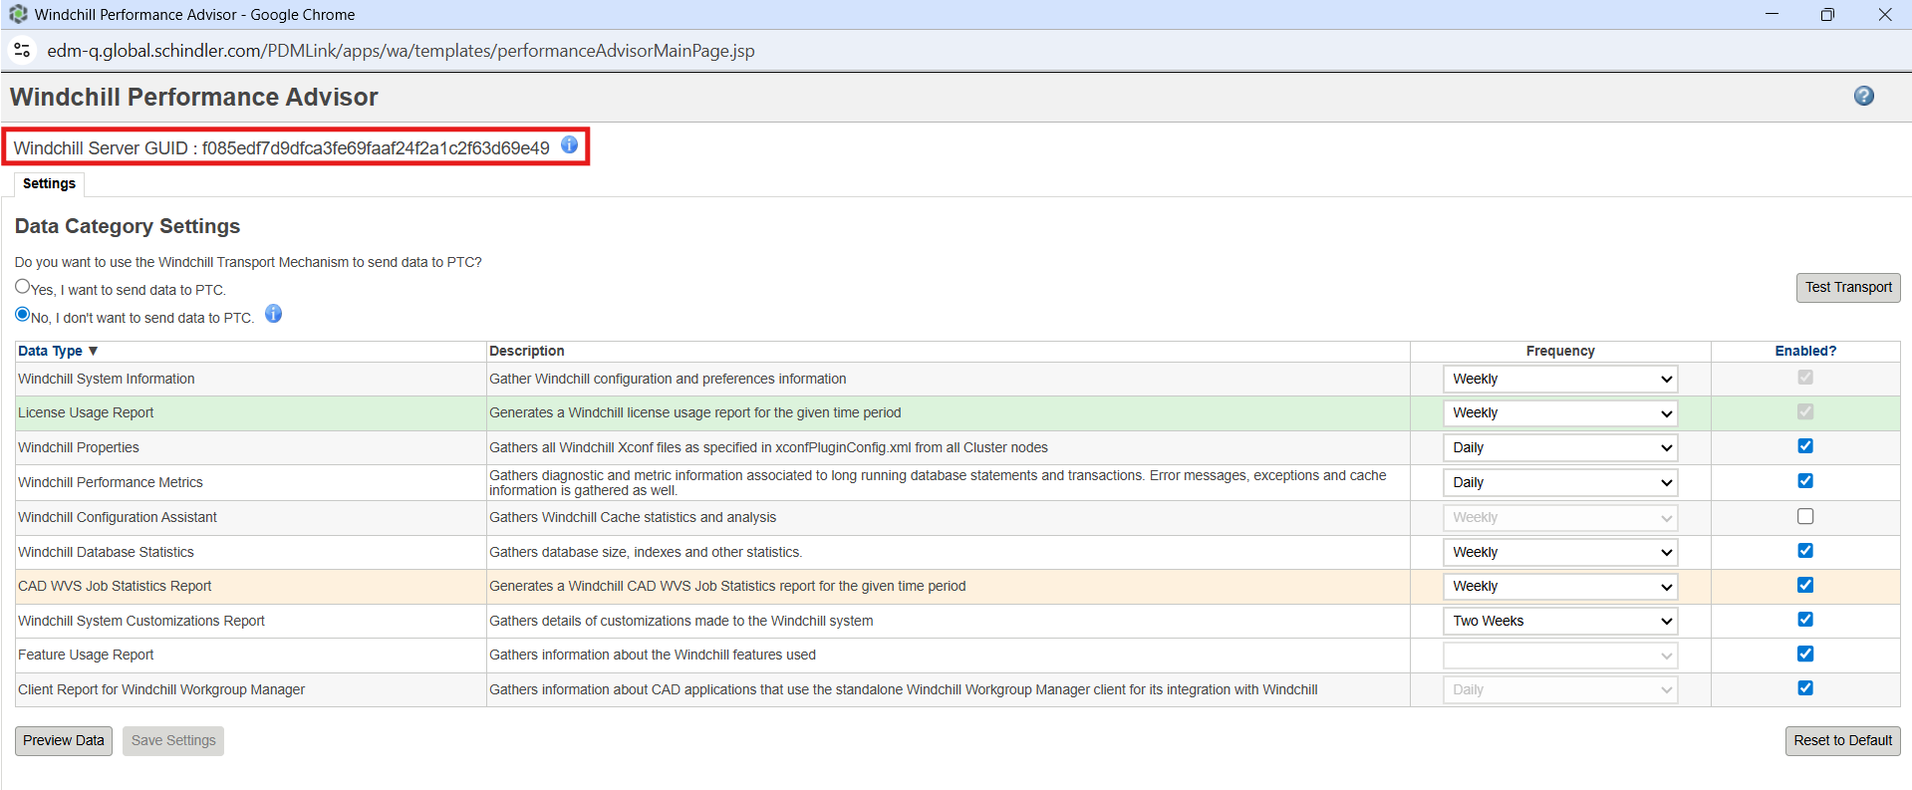

Windchill 13 Dev Server GUID : 9458990ebcd2cde83ef05f10da0f53848084e691
Windchill 13 QA Server GUID : f085edf7d9dfca3fe69faaf24f2a1c2f63d69e49
- Run below query in database to confirm new PTC_WNC_Internal rows in created
select * from Repository;
Dev Server :
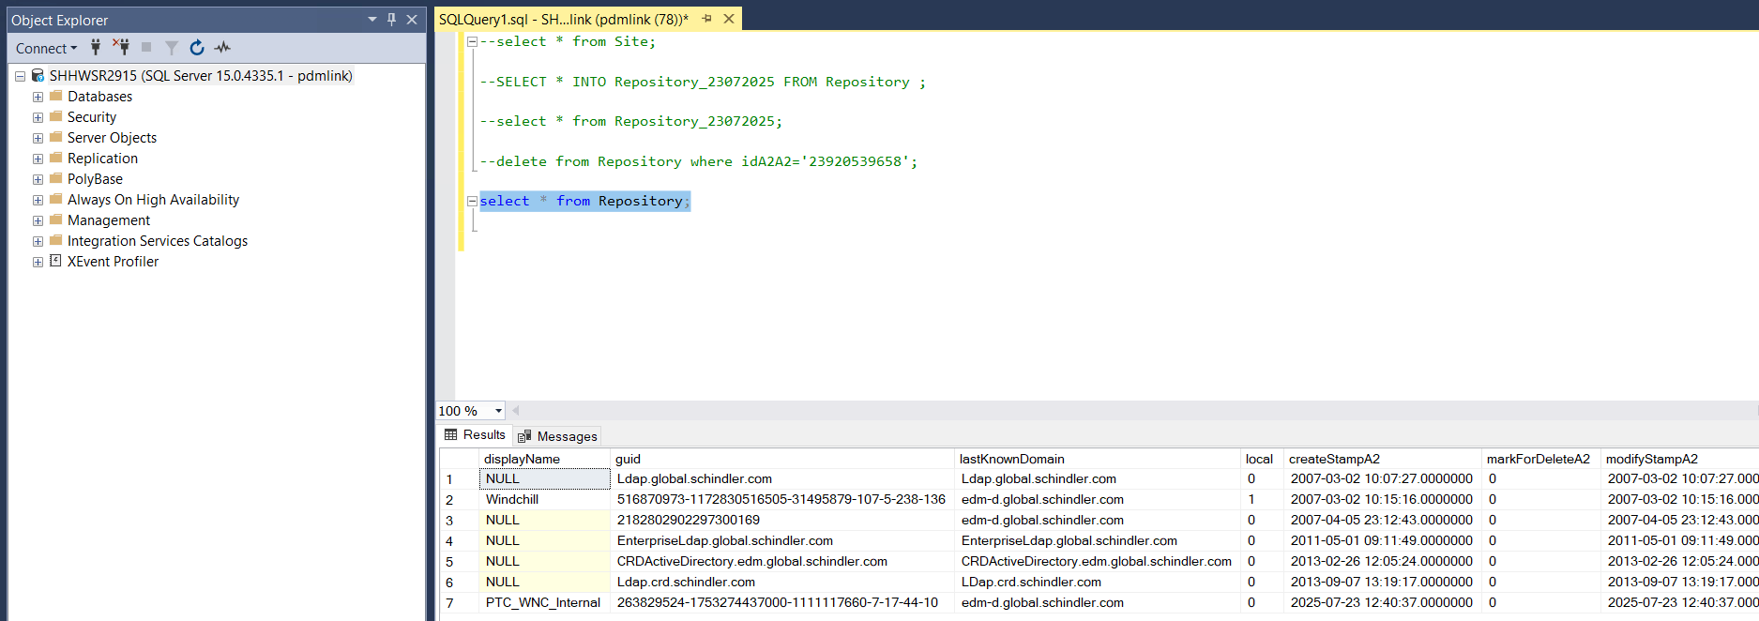
QA Server:
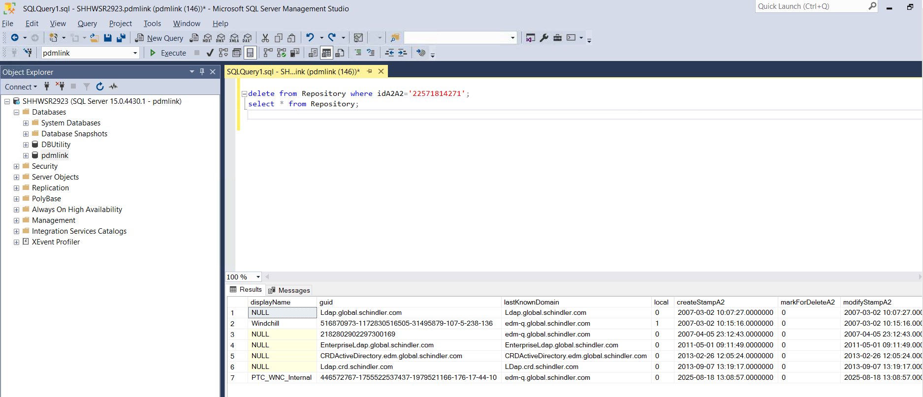
Windchill 13 Dev Server PTC_WNC_Internal : 263829524-1753274437000-1111117660-7-17-44-10
Windchill 13 QA Server PTC_WNC_Internal : 446572767-1755522537437-1979521166-176-17-44-10

Enable Performance Advisor
Navigate to Site > Utilities > Preference Management
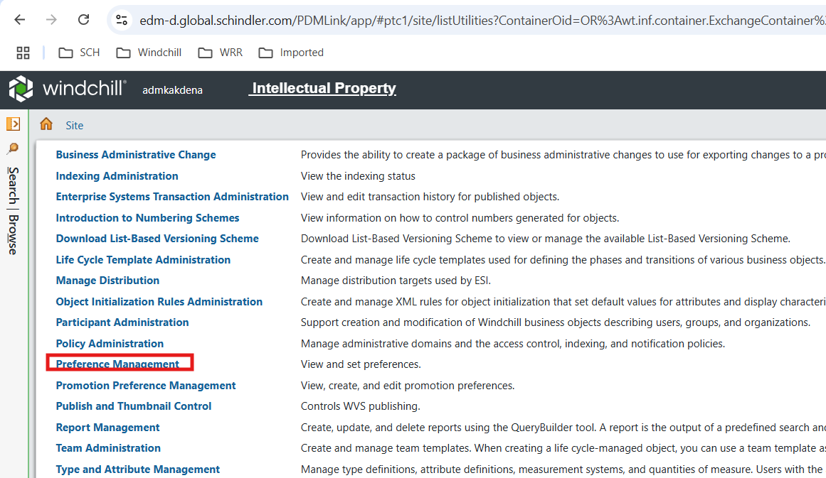
- Set Windchill Performance Advisor Activation preference value to Yes
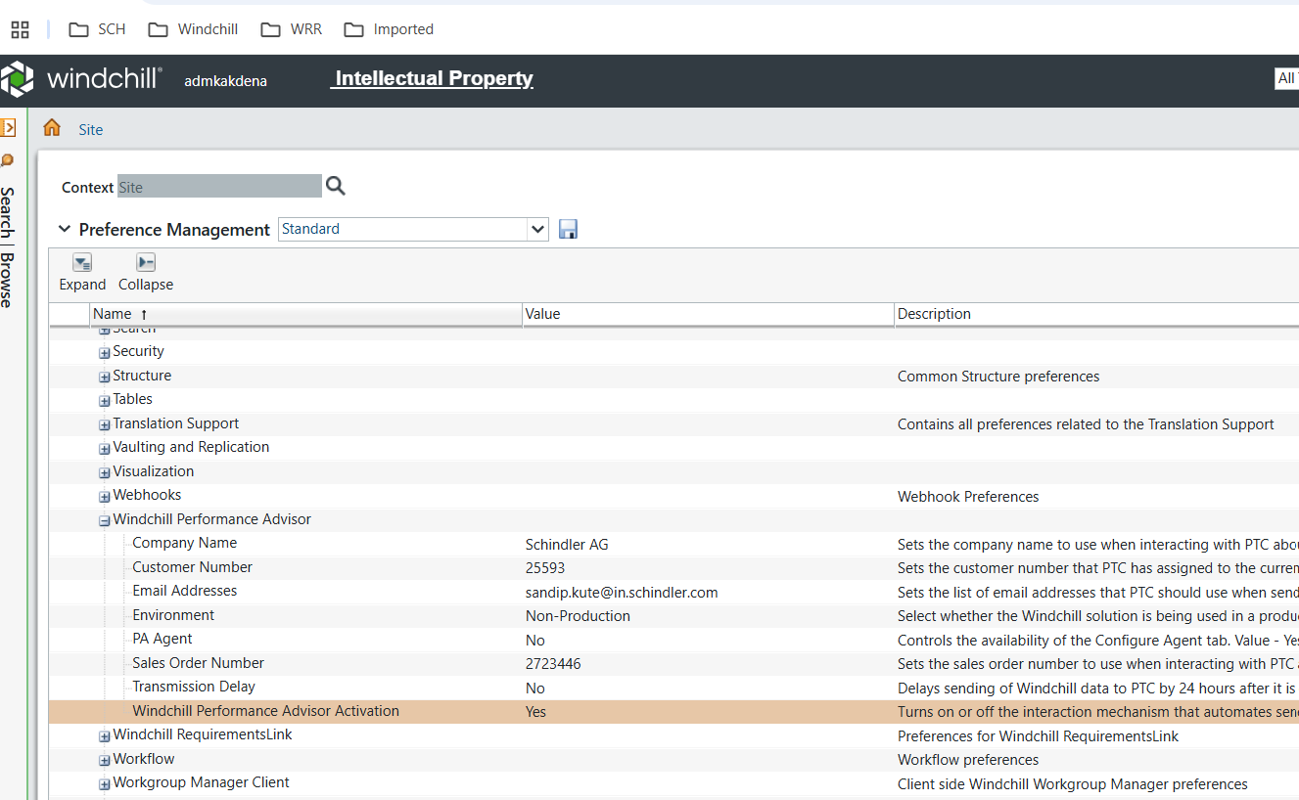

Test Transport
- Import ptc ssl certificate mentioned in issues and resolution steps of this document before Test Transport
- Navigate to Windchill Performance Advisor Dashboard and Click on Test Transport

Validate WPA Dashboard
- Data on WPA dashboard is available post 24 hours after enabling the WPA
- Log in to PTC eSupport portal and Click on Performance Advisor - System Dashboard
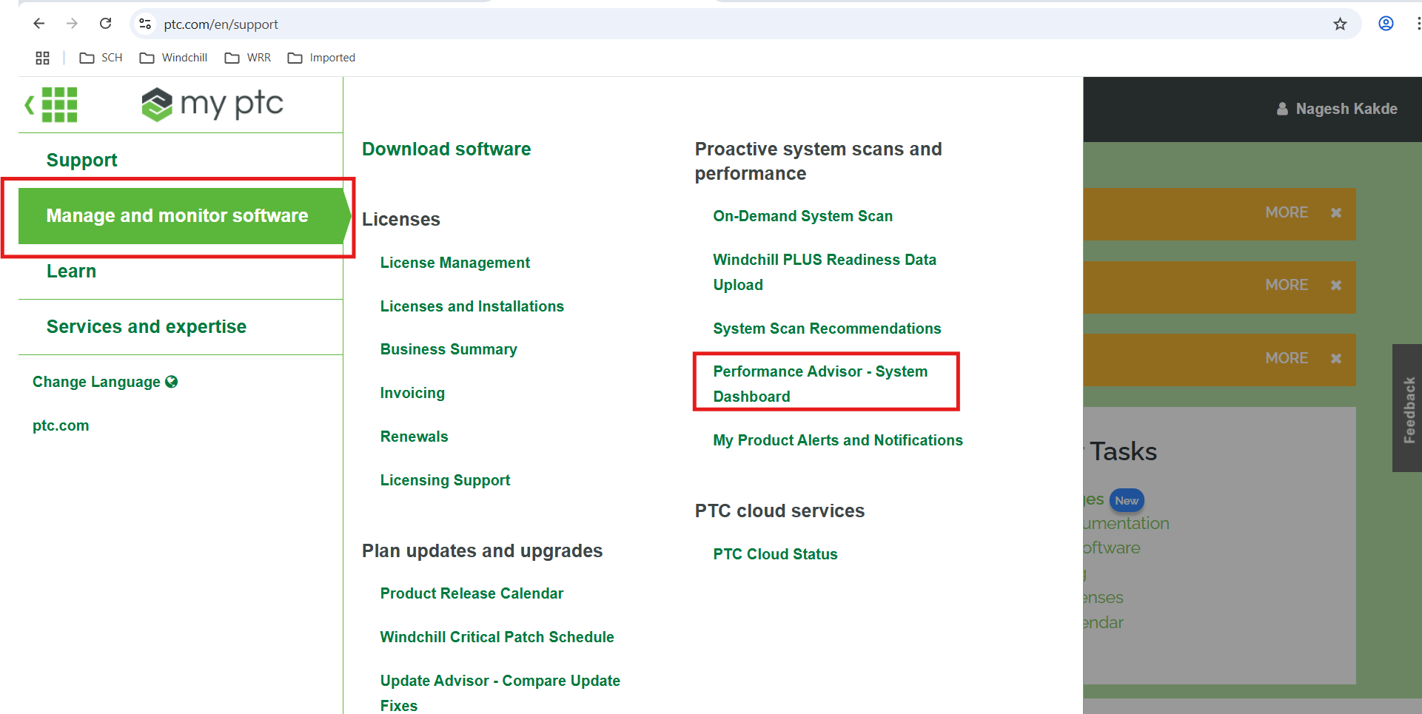

Issues and Resolution

Test Transport Failed

Issue
- Test Transport failed after clicking on Test Transport from Windchill Performance Advisor
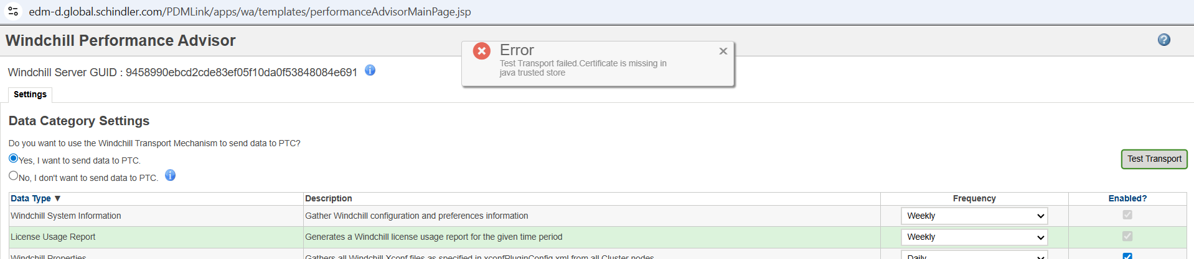
- Error in MS logs
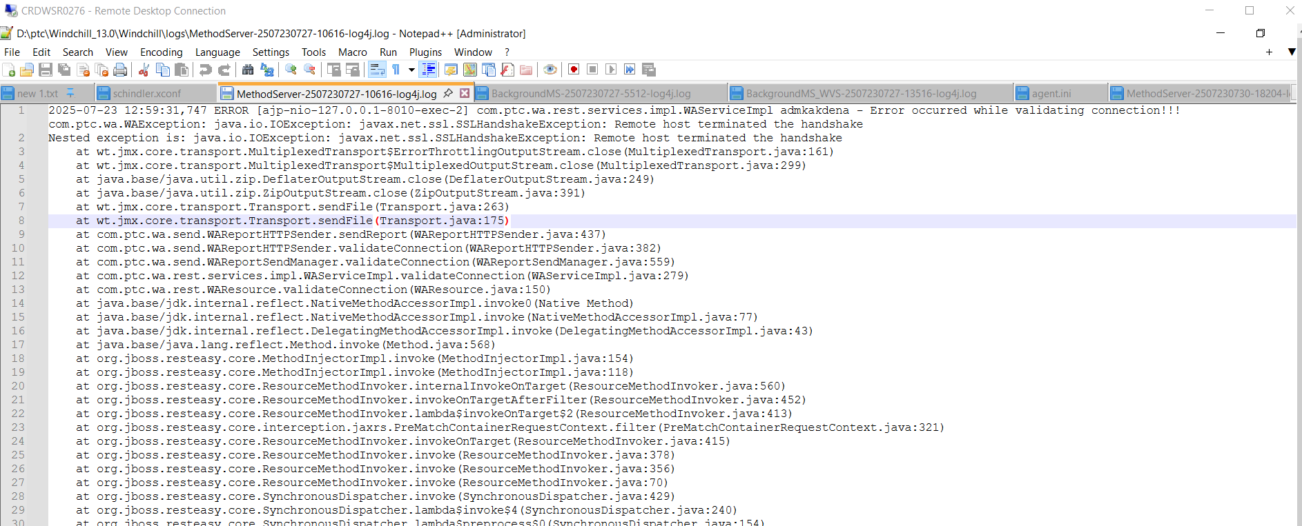

Resolution
- Open a Windchill shell, and move to the directory D:\ptc\Windchill_13.0\HTTPServer\bin
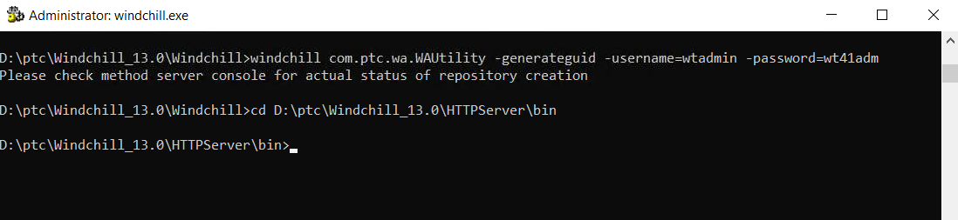
- Run: openssl
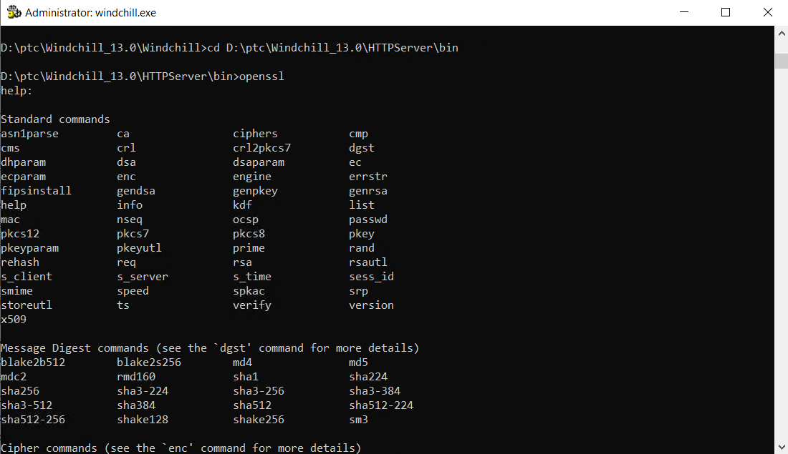
- Run s_client -connect apps.ptc.com:443
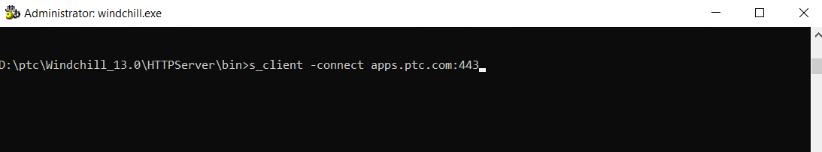
- This gets the certificate information, copy the section of text beginning with
----BEGIN CERTIFICATE---- through ----END CERTIFICATE----
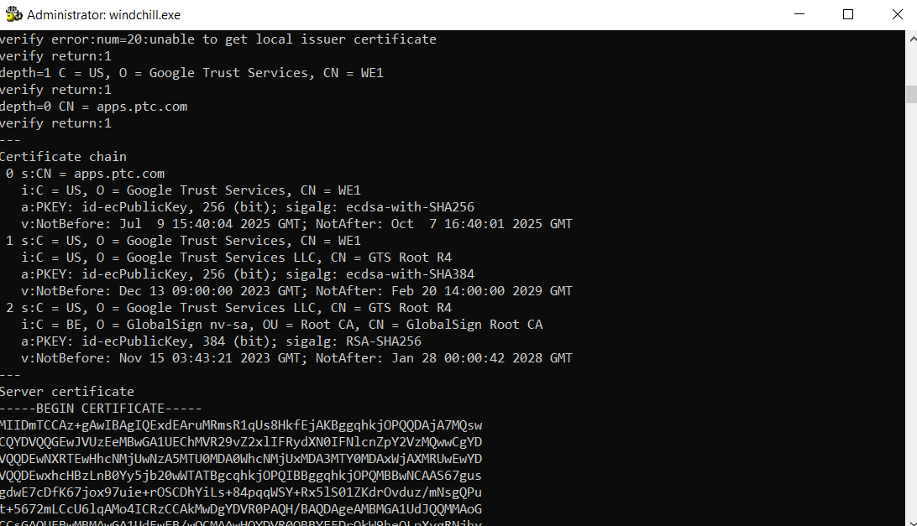

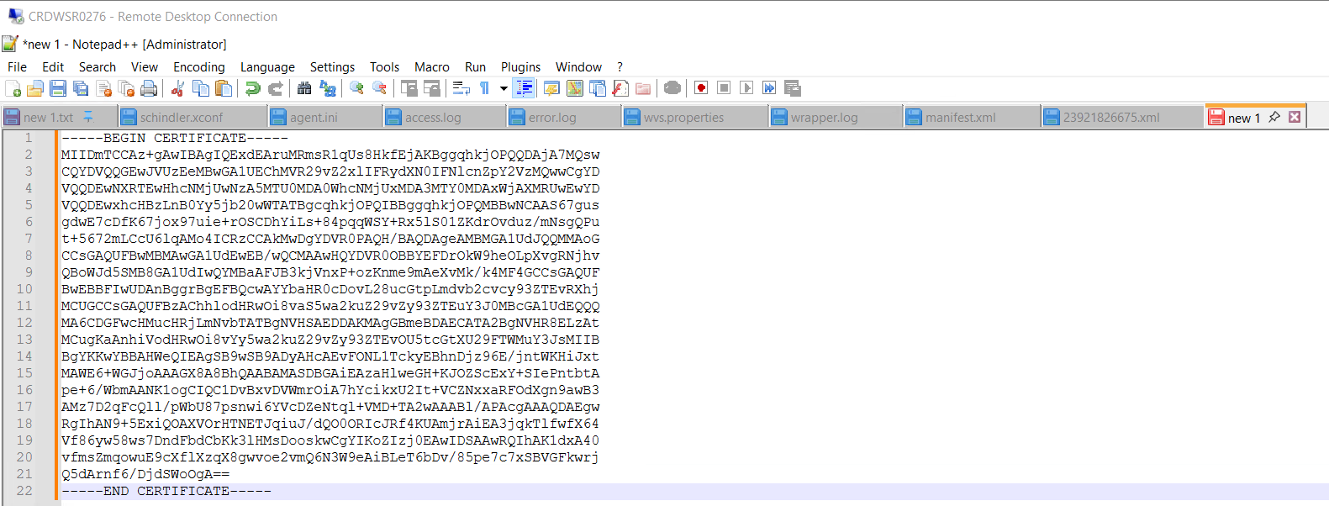
- save it as apps_ptc_com.cer
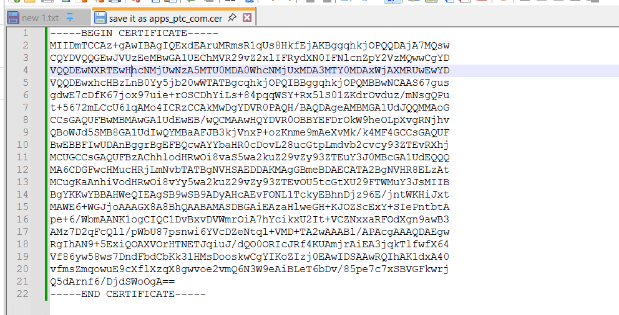

- Import this certificate into java certificate store using the following command:
keytool -import -alias PTC -file "D:\ptc_staging\wpa\apps_ptc_com.cer" -storetype JKS -keystore D:\ptc\Windchill_13.0\Java\corretto\jdk17.0.11_9\lib\security\jssecacerts -storepass changeit
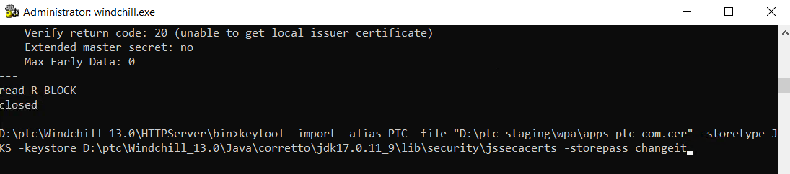

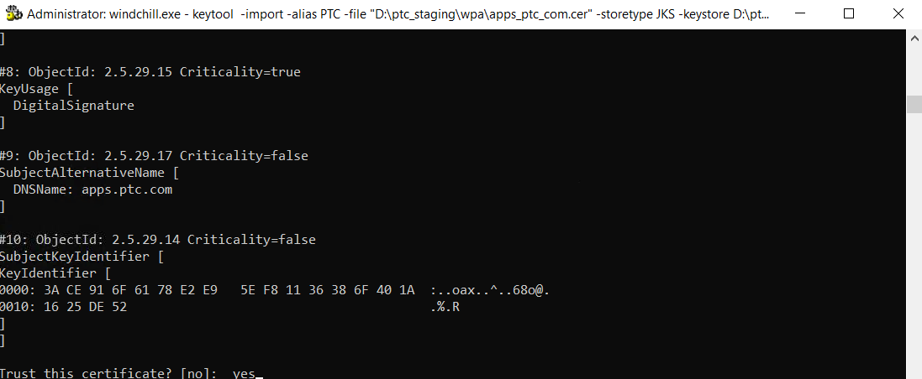

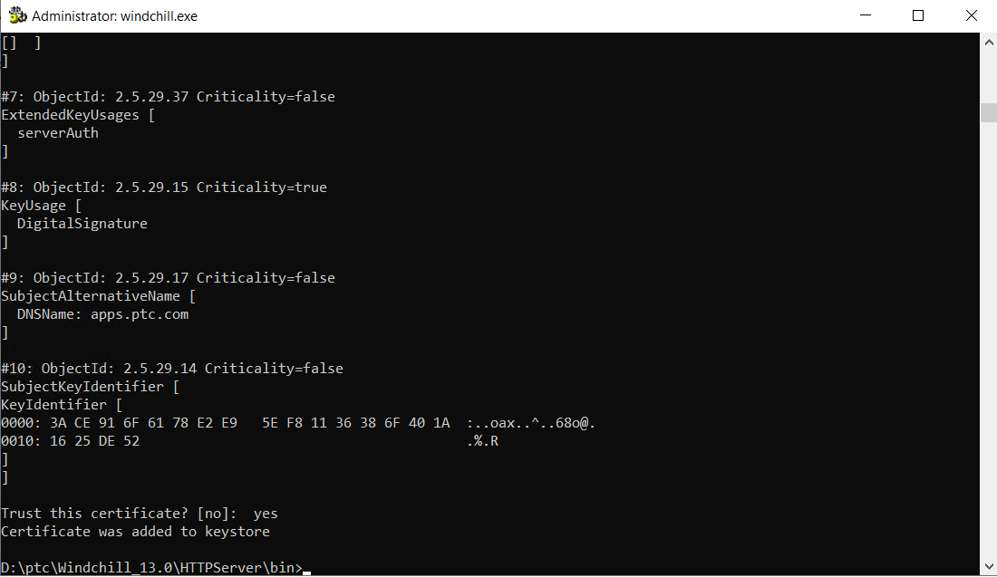
- Restart Windchill and test Transport from Site > Utilities > Windchill Performance Advisor
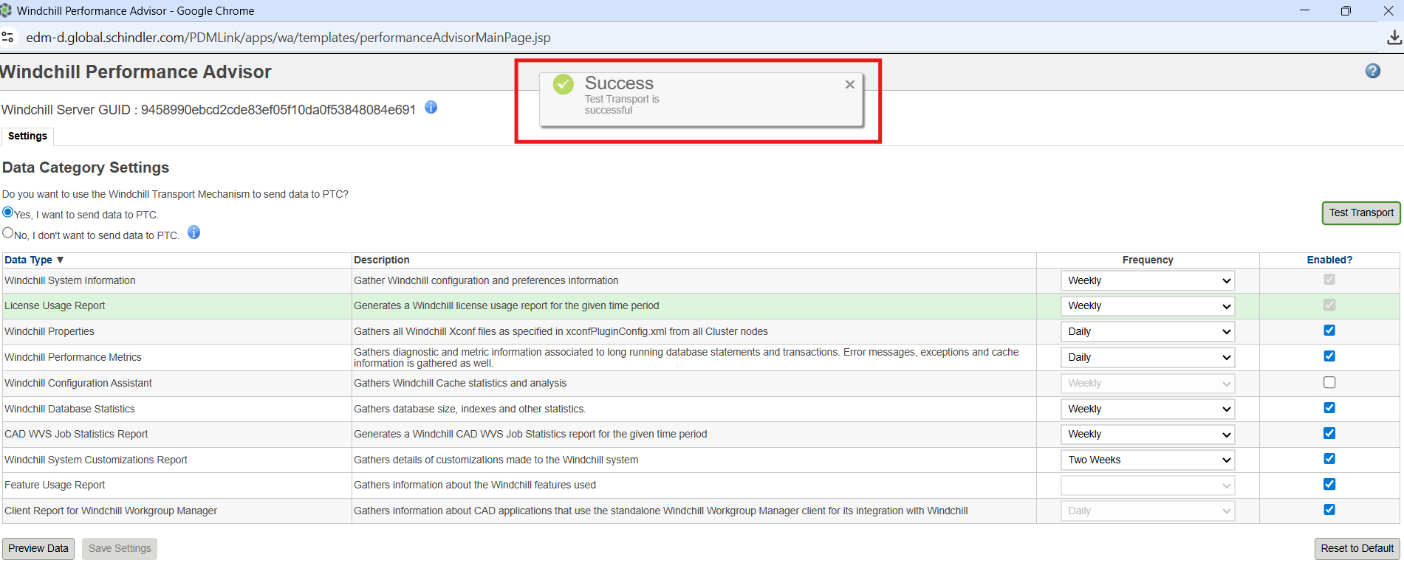

SSL handshake has read 0 bytes and written 325 bytes

Issue
- Getting SSL handshake has read 0 bytes and written 325 bytes while generating SSL certificate of apps.ptc.com
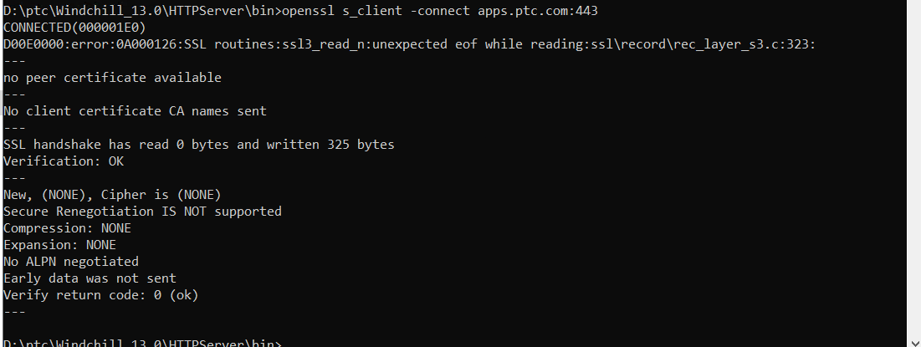

Resolution
- Firewall need to open by creating ITSM/Service Now ticket with network team as per PTC Article https://www.ptc.com/en/support/article/CS421156?source=search
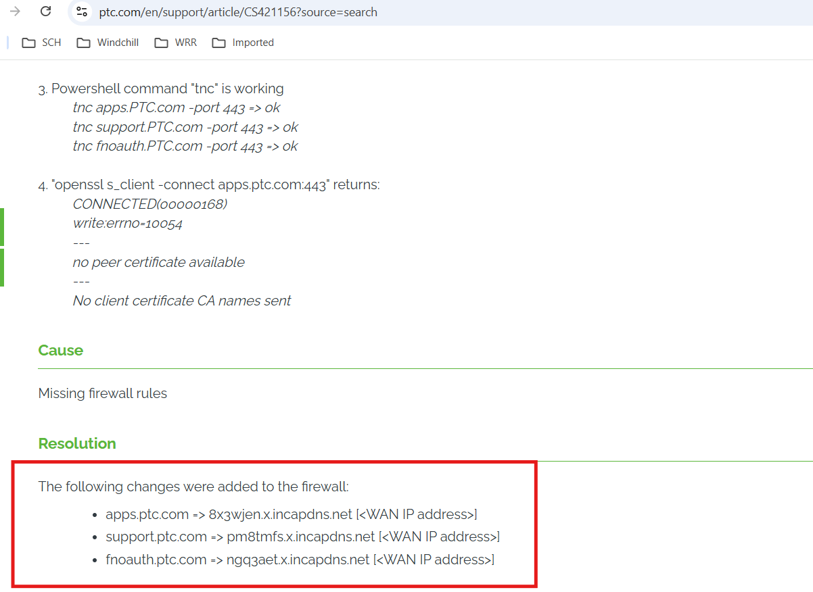
- <Need to add ITSM Ticket Number>

References
- SQL Queries
--select * from Site;
--SELECT * INTO Repository_23072025 FROM Repository ;
--select * from Repository_23072025;
--delete from Repository where idA2A2='23920539658';
--select * from Repository;
- PTC Case
https://support.ptc.com/app/caseviewer/?case=17885738&source=casetracker
- PTC Articles
https://www.ptc.com/en/support/article/CS236036
https://www.ptc.com/en/support/article/CS236189
https://www.ptc.com/en/support/article/CS421156

